We didn’t start the Fire Project

Billy Joel’s famous song captures people, places, events, trends etc from 1949-1989. We have studied various types of history in class including: Social, Political, Economic, Religious, Military, Governmental and you will have to identify these types of history in your powerpoint. You will choose 5 of the items he mentions in the stanza you were given and you need to explain the event in under 40 words and describe its significance in under 40 words as well (80 words total).

Choose the 5 terms you will explain to the class (there are usually 5-7 per stanza). Use a powerpoint / imovie/ Prezi / presentation format of your choice. For each term you need the following
1. 2 Pictures
2. Clearly Identify in bold the type(s) of history it is (Social, Political, Economic, Religious, Military, Governmental)
3. A 40-word (MAX) explanation of the historical item (in your own words – no plagiarism)
4. An explanation of the historical significance of the item (why is it important / the “so what”). (40 words MAX).

*A note on presentations: for those who are shy, choose an option that does not require you to stand up in front of the class. (Imovie with voiceover, or other option). We will also watch a video on how not to make a presentation - https://www.youtube.com/watch?v=MjcO2ExtHso (Death by Powerpoint) + Presentation skills:
https://www.youtube.com/watch?v=whTwjG4ZIJg (Doug Jeffries on Effective Public Speaking)

A PLACE TO START
http://www.school-for-champions.com/history/start_fire_facts.htm#.VzW98vkrLIW

Grading Rubric for “We Didn’t Start the Fire” Cold War Era Project

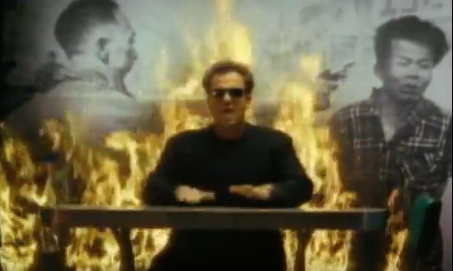
During your life, you will be called upon to do some sort of presentation. It may be for your job, your post-secondary schooling, for a wedding, a family event, or for a funeral. For some it is a debilitating thought, but it is an important skill to try to finesse before you leave school.

Since this is a history course, the research & assignment make up the bulk of your grade. However, the class is depending on you for their learning in this unit, so you need to present & be in attendance.

GRADING RUBRIC | 1 | 2 | 3 | 4
Research and information  /18 | Very few details  61+ words (Per item)  Misses significance or  does not include for most  Irrelevant & only  vaguely related to history  in class; forgets significance  at times or under/over word  limit  Has 1-2 items  Has 1 picture at times, &  forgets on some items.  Heavily Plagiarized | Vague - few details  51-60 words (Per item)  Misinterprets/does not fully  demonstrate significance, may  forget significance for items,  may exceed / not meet word  limit  Many irrelevant items / and  Does not explain statements  Has 3 items  Has 1 picture per item  In own words | Many of the important  details are judiciously chosen  41-50 words (per item)  Good work on explaining  significance on all items, but  exceeds word limit at times  Mostly relevant &  mostly explains statements  Has 4 items  Has 2 pictures for most  items. Sometimes 1.  In own insightful words | Best/concise details chosen  40 words or under (for item)  Clearly explains importance  and significance of all items  40- words per significance  Relevant & clearly  explains statements  Has 5 items  Has 2 pictures per item  In own words; developed  with clarity and insight
Presentation Rubric  /4 | Does not keep interest  Very hard to follow  Product has many  Flaws in understanding,  Teamwork, etc. | Needs work to get  Audience interested  Hard to follow  Product has flaws, but  makes some sense.  Visually needs work  Needs work to keep  audience on task | Engaging & interesting  Flows relatively well  Product is good and  Has minimal flaws  Visually few flaws  Keeps audience interested | Engaging & interesting  Flows well  A polished product  with few flaws  Visually appealing  Keeps audience interested

Your Score /22

Teacher Comments:

