Due:
American History Biography Project
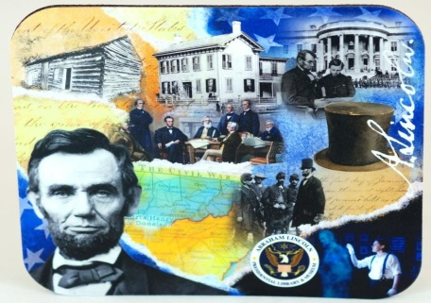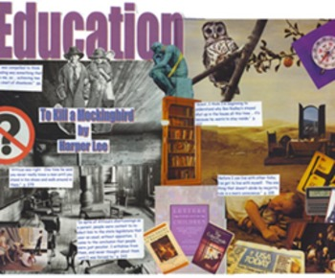
STEP ONE:
1. Choose ONE American figure that we have discussed this semester and that you have found interesting.
2. For your figure you will be researching and presenting the following information:
• Who: Who is your person?
• What: Describe what this person did to become famous (or infamous) in America. What were the short and long term effects of their actions? Include interesting facts about this person.
• When: When were they born, when did they live (describe the time period), when did their important contribution to history take place, when did they die?
• Where: Where were they born, where did their achievements take place, where did they die?
• How: How were they able to make an impact on American history? How did their actions help or hurt American history?
• Why: Why do we still study them TODAY? Why is their name still looked upon as important? Why do YOU think they are important?
STEP TWO:
Make a collage that demonstrates the following:
- Answers the who, what, when, where, how, and why discussed above
- The time period in which they lived
- A picture of the person
- A symbol or picture describing their importance
- Anything else that represents your figure
The collage may be hand drawn, from magazines, and/or may include pictures from the Internet. Your collage should include at least 10 different pieces. These may be in picture or word form. Good Luck!
Rubric:
Information: 30%
Creativity: 20%
Collage: 40%
Presentation: 10%

